**Leader Overview**

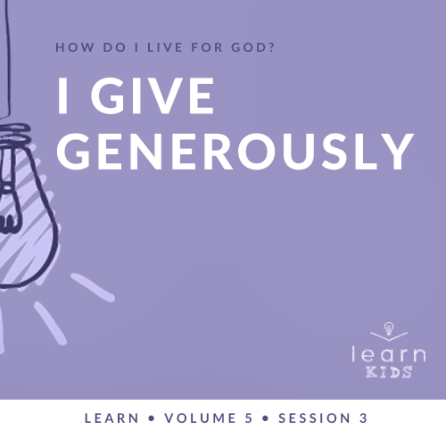

**Volume Overview**

**How do I live for God?**

*As we learn how to live for God, we’ll explore what that looks like in our everyday life. We know the Bible speaks to us, and God wants each of us to live connected to other believers. So, since that’s all true, how do we put God first? How do we get through all the confusion and uncertainty in this world? What does God expect when it comes to giving? How can we show others we care? In these sessions, we’ll consider what the Bible has to say in response to very important questions like these*.

**Session Overview**

**I Give Generously**

*When we think of giving, we often assess the value by only looking at the size of the gift. Jesus surprised people by praising a widow’s simple gift at the temple. Jesus noted that her small gift was generous because it was likely all she had. Giving generously isn’t limited to only those who can give the most valuable gift. It’s about giving from the heart even when it’s not easy to do so*.

**Bible Lesson**

A Widow’s Offering

[Mark 12:41–44](https://ref.ly/logosref/Bible.Mk12.41-44)

**Faith Fact**

I give generously.

**Faith Verse**

[Matthew 6:33](https://ref.ly/logosref/Bible.Mt6.33) (NLT)

“Seek the Kingdom of God above all else, and live righteously, and he will give you everything you need.”

**Preparing for the Session**

**Leader Preparation Time: 20–25 Minutes**

|  |
| --- |
| ***You Will Need***  ***Large Group***   * *Bible* * *Worship songs (Song suggestions: “Chain Reaction” by River Valley Worship; “Only Wanna Sing” by Hillsong Young & Free; “Build My Life” by Passion; “Way Maker” by Leeland)* * *For groups not using a phone or tablet only, add:*   *• Projector or TV*  *• Laptop*  *•* ***Countdown60 Video****–60 seconds*  ***• Faith Fact Slide***  ***• Faith Verse Video*** *or* ***Slide***  ***• Bible Lesson Video***  ***• Teaching Point Slides 1–3***  *• Balloons, ten or more depending on the size of your group*  *• Something important to you to show the kids (ring, watch, Bible, etc.)*  *• Play money*  *• Two candy bars or similar prizes*  *• Offering container*  *• Note cards, one per kid*  *• Pencils or pens, one per kid*  ***Small Group***   * ***Small Group Group Connection Page****, one per kid* * *Pencils or pens, one per kid* * *Bibles for kids in the group to share* * *Small coins, one per group* * ***Small Group Activity Page****, one per kid* * *Pencils or pens, one per kid*   *To access session content and videos from a computer, visit:* [*BibleEngagementProject.com/downloads*](https://bibleengagementproject.com/downloads) |
| ***Getting Ready***  ***Large Group***   * *Download videos and slides if needed.* * *Select worship song(s) and have them ready to play.* * *Read the Bible Lesson Scripture to prepare for teaching time.* * *Inflate the balloons with air (not helium).*   ***Small Group***   * *Print copies of the* ***Small Group Group Connection Page****, one per kid.* * *Print copies of the* ***Small Group Activity Page****, one per kid.*   *First time leading Learn for Kids? Check out the* [Facilitator Guide](https://0b769b0ed3569ef9d18b-f88d8272f61086866d50d048b43ef630.ssl.cf2.rackcdn.com/sites/biblengagementproject/Listen_Facilitator_Guide.pdf)*.* |

**Large Group**

**30 Minutes**

*See what’s needed at the beginning of the session.*

**Introduction**

Welcome! I’m so glad you’re here. Today, we’ll talk about giving. If I could give you any gift in the world for your birthday, what would you choose? *(Allow responses.)* Those are some good gifts, and some of them cost more than others.

Now, raise your hand if you love giving someone else a gift. *(Group response)* If you could give any gift to someone you love for their birthday, who would you choose and what would you give them? *(Allow responses.)* Those are some awesome answers!

Did you know that giving to others can be even more fun than receiving gifts? God wants us to be generous givers. What do you think it means to give generously? *(Allow responses.)* Great answers! I think giving generously means giving when you don’t have to or giving more than what someone would expect from you.

**Faith Fact**

Today, we’ll talk about what it looks like to give to others and to God in a way that honors Him. Our Faith Fact for today is **I give generously**. God loves it when we give generously to Him and to others.

• *Show the* ***Faith Fact Slide***.



Let’s say it together a couple of times. Ready? **I give generously.** Great job!

**Game**

**Give It All Away**

|  |
| --- |
| ***You Will Need***   * *Balloons, ten or more depending on the size of your group* * ***Countdown60 Video****–60 seconds*   ***Getting Ready***   * *Inflate balloons with air (not helium).* |

How many of you here like to keep things clean and organized? Raise your hand. *(Group response)* Good for you! Who likes to give away things like toys and clothes you’ve outgrown? Raise your hand. *(Group response)* That might not be everyone’s favorite thing to do, so I have a game for us about giving things to others. It’s called Give It All Away. We’ll have two teams.

• *Divide the group into two teams and show them where the middle of the play area is*.

*Note: This can be played while kids are sitting also*.

I’m going to hand out some balloons. When I say, “Go,” hit the balloons in the air. Your goal is to give all the balloons on your side to the other team. You have one minute to hit them to the other side. Whichever team has given the most balloons away at the end of a minute wins. Let’s get started.

• *Play the* ***Countdown60 Video****–60 seconds*



• *If you have time, play the game again. Consider adding variations like only using one hand, linking arms with another teammate, using only their heads to push the balloons, etc*.

That was a lot of fun! Good job giving your balloons generously to the other team. Could you imagine what life would look like if people in their everyday life gave generously to others like we just did? *(Group response)* How about if people gave with that much excitement? *(Group response)* I believe that would really help us share God’s love with others.

**Worship**

The best reason we should give generously to others is because of how God gave to us. Let’s start this off by thanking Him and giving our attention to God in worship.

• *Lead the kids in singing one or two praise songs. See suggestions at the beginning of the session*.

**Bible Lesson**

Thanks for singing and worshipping with me. In our Bible story today, Jesus was teaching people what it looks like to give in a way that honors God. Remember, we can always learn something from God’s Word, so let’s pray and ask God to help us learn from this Bible story today.

**Prayer**

|  |
| --- |
| *Dear God, please help us learn from Your Word today. Help us to see how to give in a way that honors You and shows others Your love. Amen.* |

**Video Intro**

Just before we look at the Bible story, let’s watch this video.

• *Play* ***Bible Lesson Video***.

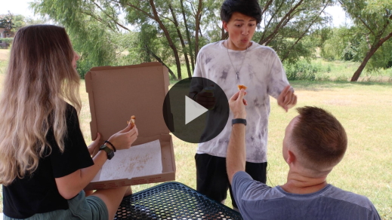

**Bible Story**

**A Widow’s Offering**

Earlier we talked about the kinds of gifts we like to receive and the gifts we would give if we could give whatever we wanted. Could you give something that would be as amazing as those things if you didn’t have much money to spend? *(Group response)* In the Bible story, Jesus taught that we can give generously no matter how much we have. When we give, the attitude of our heart matters a lot. If you want to follow along, open your Bible to [Mark 12:41–44](https://ref.ly/logosref/Bible.Mk12.41-44) or pull it up on an app. Let’s read it together.

• *Read the Bible story aloud to the group*.

• *In order to keep Large Group time moving along, we don’t recommend having the kids read*.

• *Optional: Remind the kids to mark this place with their Bible Bookmark so they can read it on their own at home*.

Why did Jesus say the widow had given more than the others when all she gave was two small coins? *(Allow responses.)* Jesus knew that even though the rich people gave a lot of money, they had given only a small percentage of what they had. Their offering didn’t cost them much. Instead, the widow honored God and trusted Him by giving everything she had. It was a big and generous sacrifice for her to give those two small coins.

**Teaching Time**

|  |
| --- |
| ***You Will Need***   * ***Teaching Point Slides 1–3*** * *Something important to you to show the kids (ring, watch, etc.)* * *Two candy bars or similar prizes* * *Play money* * *Offering container*   *No prep needed for this activity.* |

Is anyone having a hard time understanding how giving two small coins was more than the large amounts that the rich people gave? *(Group response)* Yeah, me too. Thankfully, Jesus explained it to us and helps us know why the amount the widow gave was worth more than what the rich people gave. Jesus knew everyone could give generously to God no matter how much money they had. Our Faith Fact reminds us of that. Let’s say it together. **I give generously**. Let’s learn more about why and how to do that.

**1. We give because everything we have comes from God**.

• *Show the* ***Teaching Point 1 Slide***.

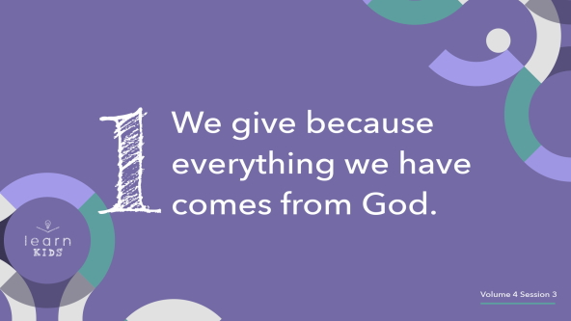

How many of you have something that you own that’s really important to you? Raise your hand. *(Group response)* Let me share about something that’s important to me.

• *Hold up a ring, watch, or something that’s important to you. Then tell the kids why it’s so important*.

Now, I’d like you to shout out what’s really important to you. *(Group response)* Those are all awesome things, and I’m glad that you have them. Maybe your important item was something you saved your money for, but most of the time our important things were given to us. Where did you get those things from? *(Allow responses.)*

• *Share how you got your important item*.

There are the things you use every day, such as food, clothes, a bed, and rooms in your home. I’m guessing your parents take care of those things. Did you know that the Bible tells us that everything we have comes from God? In [1 Chronicles 29:14](https://ref.ly/logosref/Bible.1Ch29.14), God’s Word says, “Everything we have has come from you, and we give you only what you first gave us!”

That tells us that it’s all from God even when our parents buy it or someone gives it to us.

• *Hold up your important item again*.

My important item and your important things are all from God. When we give an offering to God like the people in our Bible story, we’re simply returning to Him what He has provided for us. When we realize that God provides for us, it’s easier to be generous.

**2. We give generously and cheerfully**.

• *Show the* ***Teaching Point 2 Slide***.

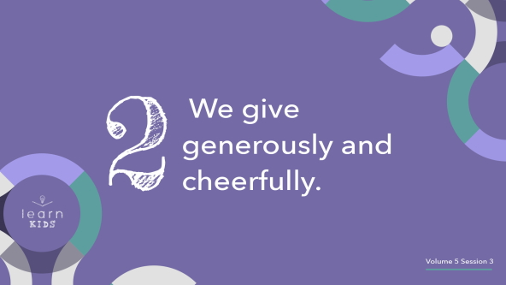

Let’s take a quick time-out and play a game. I’ll pick a number between one and one hundred. The closest guess wins.

• *Allow kids to take turns guessing the number until someone wins*.

All right, we have a winner! Come and join me. Because you won, I have a prize for you.

• *Start to hand the prize to the kid, but then pull it back*.

Wait a minute! I really wanted this for myself later. When I think about giving this to you, I really don’t want you to have it, but I guess you can take it.

• *Reluctantly give the prize to the winner and then tell them to sit down*.

Did that look like I wanted to give away the prize? *(Group response)* Is that a good way to give? *(Group response)* Of course not! We can make someone feel bad about accepting our gift with our words and our actions. That isn’t how God wants us to give. He wants us to give with the right attitude. Then, giving is fun and empowering. It brings us closer to God.

• *Choose another kid to come and stand by you*.

How much better does it sound to give with a great attitude? Listen to this. *(To volunteer)* I want you to have this because I care about you.

• *Give the treat to the volunteer*.

That’s much better! I didn’t make them win something to get the treat. I just gave it happily. That’s how God wants us to give—generously and willingly. He doesn’t want us to give because we see our friends giving and feel pressured. In [2 Corinthians 9:7](https://ref.ly/logosref/Bible.2Co9.7), God’s Word says, “You must each decide in your heart how much to give. And don’t give reluctantly or in response to pressure. ‘For God loves a person who gives cheerfully.’”

That’s not all God wants us to know about giving. God also doesn’t want us to make a huge deal about our giving and tell everyone about it.

• *Hold up some of the play money*.

If I feel that God wants me to give money in the offering, do you think He wants me to tell anyone about it or flash it all around? *(Group response)*

• *Wave it around in the air obnoxiously before placing it in the offering container*.

No, He doesn’t. I don’t think the woman in the Bible story wanted people to look at her when she gave, but some of the other people may have wanted to be noticed. Our giving shouldn’t be about what others think about us. It should be between us and God.

**3. We give regularly**.

• *Show the* ***Teaching Point 3 Slide***.

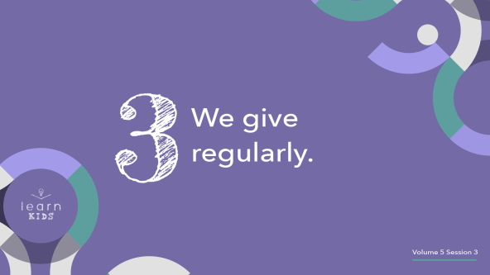

One place we can give is at church like the people in the Bible story. Imagine that I’m at church, and I give generously and cheerfully to the church one week. After giving one time, should I keep giving? *(Group response)* I definitely should keep giving. The Bible tells us to give regularly to our church. I know that God will be providing for me, so I should always be looking to give to others, too.

There are two types of giving that we should be participating in regularly. Who knows what a tithe is? *(Allow responses.)* A tithe is one-tenth or 10 percent of what you make or receive. If you get ten dollars as a birthday gift, your tithe would be one dollar because that is 10 percent of ten dollars. If you have a hundred dollars, your tithe would be ten dollars. Tithing is something we should be doing regularly as we receive money.

• *Hold up the play money while you speak about it*.

Another type of giving is an offering. You can give an offering for anything at any time. Your offering is in addition to your tithe amount. God wants us to be looking for ways that we can give to others. This is because giving to others helps to show them God’s love and can lead them to follow Jesus. When people live for God, they will become generous givers themselves.

We can all give generously in many different ways, but all of them are special and can be used to change someone else’s life. Here’s the really cool thing about giving. Giving isn’t just a money thing. We can give our time, attention, talents, things, and money to people who need it. Those are all ways we live out our Faith Fact. Say it with me. **I give generously**.

**Prayer and Response**

*Consider playing a worship song softly in the background while kids pray*.

|  |
| --- |
| ***You Will Need***   * *Note cards, one per kid* * *Pencils or pens, one per kid* * *Offering container*   *No prep needed for this activity.* |

Because there are so many ways to give, trying to figure out what to give to God can seem overwhelming. Thankfully, we can pray and ask God to lead us so that we know what to give, when to give it, and who to give it to.

We’re going to take some time and ask God what our next step is from today’s Bible teaching. Maybe it’s that you would use your talents to show God’s love. Maybe it’s that you would give a little bit of money to the church every week. After we pray, continue to seek God on your own. Then, write on the note card what you feel He wants you to give and who He wants you to give it to. Everyone, bow your head, close your eyes, and let’s ask God to speak to us.

• *Give each kid a note card and pencil*.

**Prayer**

• *Optional: Have the kids repeat phrases of the prayer after you*.

|  |
| --- |
| Dear God, thank You for teaching us how to give and that everything we have comes from You. Help us to be generous givers of our time, our talents, and our treasure. We open our heart and mind to You so that we can hear from You today. Amen. |

When you feel like you know what God wants you to give, write it down on the note card. Place the note card in the offering container.

• *Allow some time for kids to write on the note cards*.

**Faith Verse**

Our Faith Verse reminds us that we can seek God and then trust Him because all our needs will be met by Him. That’s why we can be generous with what we have and share with others.

When we seek God and ask Him for guidance instead of relying on our own strength and knowledge, He will give us what we need. Isn’t that a relief? I love knowing that it isn’t my responsibility to figure it all out on my own. God is always with us and wants to help us make the right decisions. Let’s review our Faith Verse now.

• *Play* ***Faith Verse Video***.

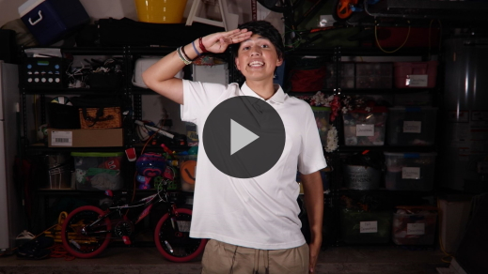

[Matthew 6:33](https://ref.ly/logosref/Bible.Mt6.33) (NLT)

“Seek the Kingdom of God above all else, and live righteously, and he will give you everything you need.”

**Faith Fact**

Before we go to our small groups, let’s review our Faith Fact again.

• *Show the* ***Faith Fact Slide***.



Say it with me. **I give generously**. Let’s do that together! It’s been great learning with you today.

• *Dismiss kids to Small Group time or to go home if your group time ends here*.

**Small Group**

**30 Minutes**

*This section can be done in conjunction with the large group or on its own if you do small groups with your kids. During Small Group time, the goal is to connect the kids with the Word of God and to each other. All activities are led by the small group leader.*

**Group Connection**

**Giving Goals Calendar**

|  |
| --- |
| ***You Will Need***   * ***Small Group Group Connection Page****, one per kid* * *Pencils or pens, one per kid*   ***Getting Ready***   * *Print copies of the* ***Small Group Group Connection Page****, one per kid.* |

Sometimes no matter how much we want to give, we forget because we were distracted. One thing we can do to help us remember to give is to write down what we plan to do. We can schedule when we’ll give generously to someone.

• *Hand out the* ***Small Group Group Connection Page*** *and a pencil to each kid*.

On this page, you can write your giving goals for the week. My challenge for you this week is to give something, even if it’s small, every day this next week. I want you to think about what you could give to someone on each specific day.

First, you might want to fill in how God directed you to give during prayer time. Then, think about who else you can give generously to. Maybe you know your mom, dad, or someone else in your family always needs extra help. Fill in how you can help them. Next, think about others. Maybe your neighbor always mows their yard on Saturday. Fill in how you can help them. Do you get an allowance? If so, plan to take your tithe to church to give.

There are many ways to give generously. We can also be generous with our kind words. Is there someone you know who needs to be encouraged? What can you say to them to show God’s love? Maybe you can create an awesome handmade card for someone you know who is sick or sad.

As you fulfill your goals this week, cross them off. Watch how your giving will encourage others and share God’s love with them. Plan to tell us next time about how you gave generously.

• *Help the kids think about things they can do to give to others*.

**Learn about It**

|  |
| --- |
| ***You Will Need***   * *Bibles for kids in your group to share*   *No prep needed for this activity.* |

**Scripture Search:** [**1 Timothy 6:17–19**](https://ref.ly/logosref/Bible.1Ti6.17-19)**;** [**2 Corinthians 9:6–7**](https://ref.ly/logosref/Bible.2Co9.6-7)**;** [**2 Corinthians 8:1–5**](https://ref.ly/logosref/Bible.2Co8.1-5)

Let’s dig deeper into God’s Word and see what else He has to say about giving generously. As we find and read each of these verses, let’s consider: What does this Scripture mean for our life today?

• *Give each kid a Bible and search for one or more of the Scriptures as a group together (as time allows). When everyone has found the Scripture, have one of the kids read it. Then, answer the questions about it*.

• *Pair kids who need additional help with older kids or start simple and look up the session’s Bible story Scripture:* [*Mark 12:41–44*](https://ref.ly/logosref/Bible.Mk12.41-44)*. Kids will get better finding Scriptures the more they practice*.

• *Optional: Make this a competition to see who can find the Scripture first*.

**Bible Reading Tip**

God’s Word is so good. Did you know that there’s a special system for finding Bible books, chapters, and verses? Near the front of your Bible, you should see page labeled Contents or Table of Contents.

• *Turn to the contents page in a Bible and hold it up*.

The contents page shows you what page a certain book of the Bible starts. When you turn to that page, use the large numbers in the text to find the chapter. When you find the right chapter, use the small numbers to find the verses.

If you use a digital Bible, finding verses uses a similar method. Start with selecting the book you want, then the chapter, and then find the verse number by scanning through the smaller numbers you see in the passage.

• *Optional: Practice this tip by finding the Faith Verse,* [*Matthew 6:33*](https://ref.ly/logosref/Bible.Mt6.33)*, and the Bible story in* [*Mark 12:41–44*](https://ref.ly/logosref/Bible.Mk12.41-44).

**Challenge**

This week, practice looking up one verse a day. You might want to ask your parents to suggest a verse to look up. See if you can remember how to find these verses.

**Faith Fact**

All of our Bible reading is a reminder to me of our Faith Fact. Say it with me: **I give generously**.

**Group Discussion**

*Feel free to use all or just a few questions as a jumping-off place for good discussion. Questions marked with * are designed for more conversation. Adjust the questions based on the age or maturity of your group. Typically, older kids will be able to dive a little deeper than younger ones*.

**Questions**

• *If small group activities are not immediately following large group time, you may want to read the Bible story passage before this discussion*.

In our Bible story, who did Jesus notice giving at the temple?

Who did Jesus say gave more and why?

* How would you describe the difference between normal giving and generous giving? Can you give me an example?

Where does everything we have come from?

* How does God give generously to us?

* Why should knowing God takes care of us make it easier for us to give?

What attitude should we have about giving? Why?

* What ways can we give to others around us?

* Have you ever felt God directing you to give? Share about it with the group if you feel comfortable.

What is something that would be hard for you to give? Why?

What does giving to others do for them and their heart?

What does our Faith Verse tell us we should seek above all else and why?

**Prayer Requests**

*Finish group discussion by sharing prayer requests and praise reports. Keep track of your small group’s prayer requests and review them each time you meet*.

**Prayer**

*Have kids pray for each other’s prayer requests*.

**Faith Verse Review**

|  |
| --- |
| ***You Will Need***   * *Small coins, one per group*   *No prep needed for this activity.* |

Our Faith Verse is [Matthew 6:33](https://ref.ly/logosref/Bible.Mt6.33). It tells us that when we seek God’s kingdom and honor God’s ways, He takes care of our needs. Let’s watch the ***Faith Verse Video*** and do the actions together.

[Matthew 6:33](https://ref.ly/logosref/Bible.Mt6.33) (NLT)

“Seek the Kingdom of God above all else, and live righteously, and he will give you everything you need.”

• *Show* ***Faith Verse Video***.



**Faith Verse Fun**

**Secret Giving**

Let’s say our Faith Verse as we play a game. I’ll choose one person to be It, and they will turn away from the group. The rest of the group will pass a coin. When you get the coin, you’ll have to say the next word in the Faith Verse. There’s a catch. I’ll choose someone in the group to be the Giver. When you’re done saying the verse, the Giver will decide who gets to keep the coin.

When one kid has the coin, everyone in the group will press your hands together like you’re holding something. Then, the person who’s It will turn around and guess who has the coin.

• *Choose someone to be It and someone to be the Giver. Then, play the game*.

• *Let the person who has the coin choose who gets to be It for the next round*.

**Activity Page**

**Message to Remember**

|  |
| --- |
| ***You Will Need***   * ***Small Group Activity Page****, one per kid* * *Pencils or pens, one per kid*   ***Getting Ready***   * *Print copies of the* ***Small Group Activity Page****, one per kid.* |

I’ve got a challenge for you today. You’ll need to unscramble words from our Bible story about the widow who gave generously. Let’s look at the page.

• *Hand out a* ***Small Group Activity Page*** *and pencil to each kid*.

As you unscramble the words, you’ll see that some letters are circled. Copy those letters to the spaces below the puzzle for a special message to remember.

• *Give kids time to work on the activity. Provide help if the words are too difficult for some of the kids*.

**Dismissal**

Let’s remember that God generously gives us everything we need. We can trust that when we give generously to show His love to others, He will provide for us. Knowing that, we can give cheerfully to those around us who need it.

**Prayer**

|  |
| --- |
| *Dear God, thank You for providing for all of our needs. Help us to give generously with a cheerful heart. We want those around us to see Your love in action. Let our giving be something that honors You. Amen.* |

**Faith Fact Recap**

• *Show the* ***Faith Fact Slide***.



I want you to remember today’s Faith Fact. Let’s say it together. **I give generously**. I’m glad you came today. I can’t wait to see you next time.

• *Send home the* ***Small Group Activity Page*** *and the* ***Small Group Group Connection*** *page*.

• *Remind parents that there are* ***Family Devotions*** *available on the app to do with their kid*.

• *Tell everyone the date and time for the next session*.